**WEKA application**

**DATASET Information and ARFF file**

WEKA IMAGE FOR APPLIED TECHNIQUES

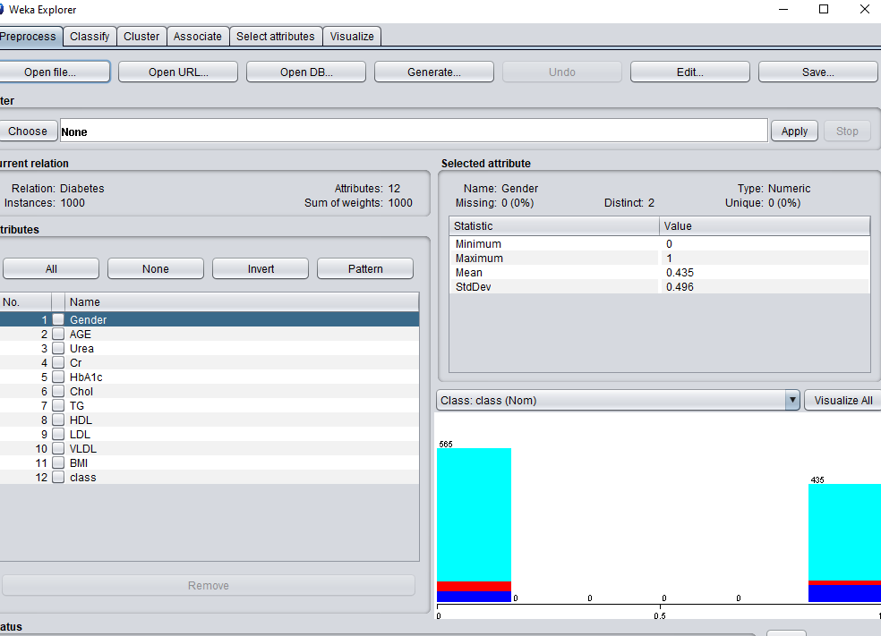

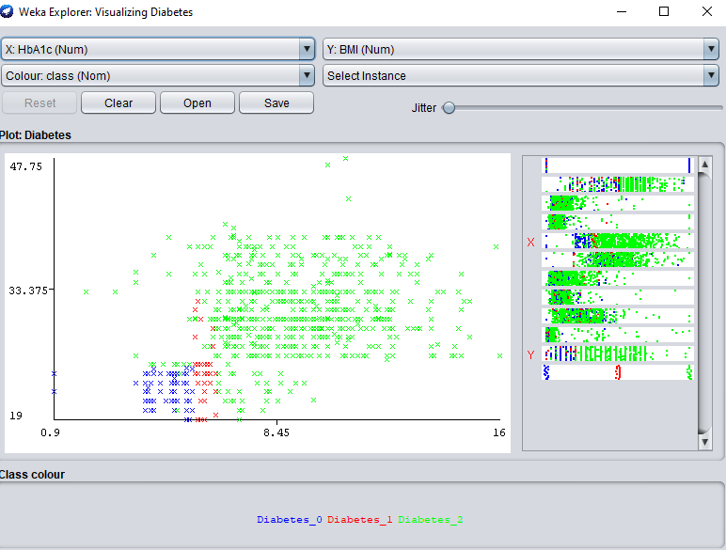

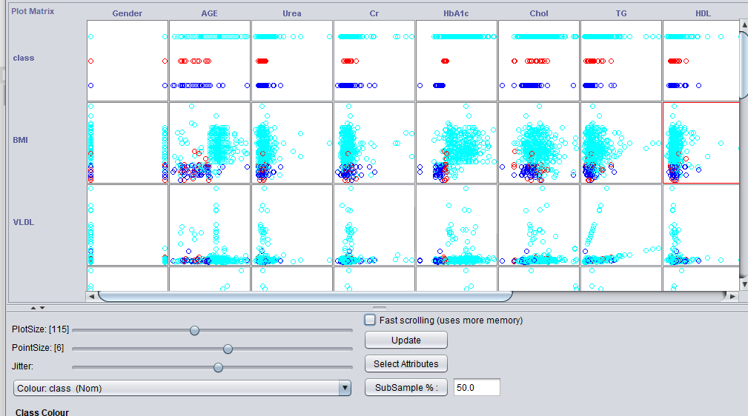

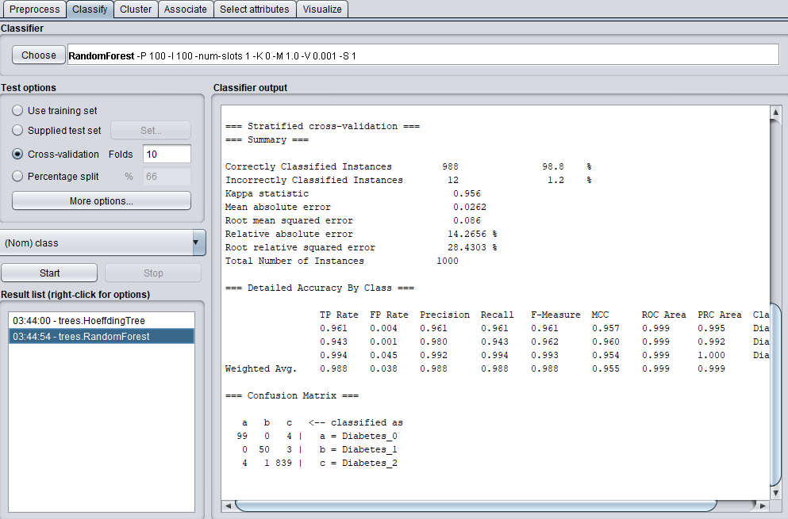

=== Run information ===

Scheme: weka.classifiers.trees.RandomForest -P 100 -I 100 -num-slots 1 -K 0 -M 1.0 -V 0.001 -S 1

Relation: Diabetes

Instances: 1000

Attributes: 12

Gender

AGE

Urea

Cr

HbA1c

Chol

TG

HDL

LDL

VLDL

BMI

class

Test mode: 10-fold cross-validation

=== Classifier model (full training set) ===

RandomForest

Bagging with 100 iterations and base learner

weka.classifiers.trees.RandomTree -K 0 -M 1.0 -V 0.001 -S 1 -do-not-check-capabilities

Time taken to build model: 0.24 seconds

=== Stratified cross-validation ===

=== Summary ===

Correctly Classified Instances 988 98.8 %

Incorrectly Classified Instances 12 1.2 %

Kappa statistic 0.956

Mean absolute error 0.0262

Root mean squared error 0.086

Relative absolute error 14.2656 %

Root relative squared error 28.4303 %

Total Number of Instances 1000

=== Detailed Accuracy By Class ===

TP Rate FP Rate Precision Recall F-Measure MCC ROC Area PRC Area Class

0.961 0.004 0.961 0.961 0.961 0.957 0.999 0.995 Diabetes_0

0.943 0.001 0.980 0.943 0.962 0.960 0.999 0.992 Diabetes_1

0.994 0.045 0.992 0.994 0.993 0.954 0.999 1.000 Diabetes_2

Weighted Avg. 0.988 0.038 0.988 0.988 0.988 0.955 0.999 0.999

=== Confusion Matrix ===

a b c <-- classified as

99 0 4 | a = Diabetes_0

0 50 3 | b = Diabetes_1

4 1 839 | c = Diabetes_2

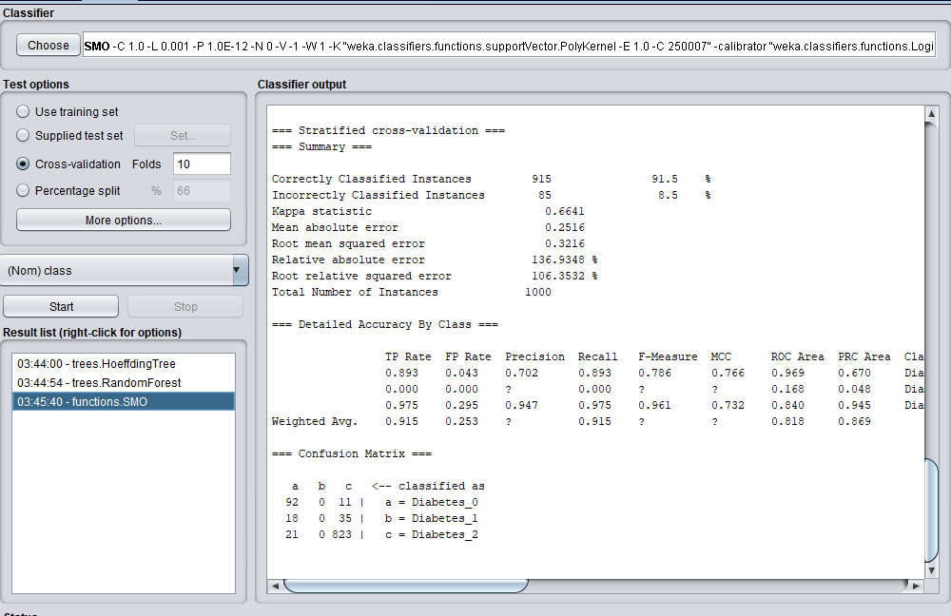

=== Run information ===

Scheme: weka.classifiers.functions.SMO -C 1.0 -L 0.001 -P 1.0E-12 -N 0 -V -1 -W 1 -K "weka.classifiers.functions.supportVector.PolyKernel -E 1.0 -C 250007" -calibrator "weka.classifiers.functions.Logistic -R 1.0E-8 -M -1 -num-decimal-places 4"

Relation: Diabetes

Instances: 1000

Attributes: 12

Gender

AGE

Urea

Cr

HbA1c

Chol

TG

HDL

LDL

VLDL

BMI

class

Test mode: 10-fold cross-validation

=== Classifier model (full training set) ===

SMO

Kernel used:

Linear Kernel: K(x,y) = <x,y>

Classifier for classes: Diabetes_0, Diabetes_1

BinarySMO

Machine linear: showing attribute weights, not support vectors.

-0.5362 * (normalized) Gender

+ -0.338 * (normalized) AGE

+ -0.5521 * (normalized) Urea

+ -0.0344 * (normalized) Cr

+ 3.7899 * (normalized) HbA1c

+ 0.5185 * (normalized) Chol

+ 1.3293 * (normalized) TG

+ -0.3585 * (normalized) HDL

+ -0.3645 * (normalized) LDL

+ -0.2913 * (normalized) VLDL

+ 2.5828 * (normalized) BMI

- 1.8277

Number of kernel evaluations: 2116 (60.038% cached)

Classifier for classes: Diabetes_0, Diabetes_2

BinarySMO

Machine linear: showing attribute weights, not support vectors.

-0.2538 * (normalized) Gender

+ 1.2563 * (normalized) AGE

+ 0.1681 * (normalized) Urea

+ 0.1289 * (normalized) Cr

+ 5.2187 * (normalized) HbA1c

+ 2.3471 * (normalized) Chol

+ 2.0273 * (normalized) TG

+ 0.1696 * (normalized) HDL

+ 0.6173 * (normalized) LDL

+ 1.0143 * (normalized) VLDL

+ 4.5919 * (normalized) BMI

- 4.3053

Number of kernel evaluations: 8719 (71.569% cached)

Classifier for classes: Diabetes_1, Diabetes_2

BinarySMO

Machine linear: showing attribute weights, not support vectors.

0.0788 * (normalized) Gender

+ 0.2652 * (normalized) AGE

+ 0.3792 * (normalized) Urea

+ 0.1428 * (normalized) Cr

+ 0.4122 * (normalized) HbA1c

+ 0.5473 * (normalized) Chol

+ -0.0619 * (normalized) TG

+ 0.3653 * (normalized) HDL

+ 0.2997 * (normalized) LDL

+ 0.6606 * (normalized) VLDL

+ 0.7735 * (normalized) BMI

+ 0.0897

Number of kernel evaluations: 13480 (71.113% cached)

Time taken to build model: 0.05 seconds

=== Stratified cross-validation ===

=== Summary ===

Correctly Classified Instances 915 91.5 %

Incorrectly Classified Instances 85 8.5 %

Kappa statistic 0.6641

Mean absolute error 0.2516

Root mean squared error 0.3216

Relative absolute error 136.9348 %

Root relative squared error 106.3532 %

Total Number of Instances 1000

=== Detailed Accuracy By Class ===

TP Rate FP Rate Precision Recall F-Measure MCC ROC Area PRC Area Class

0.893 0.043 0.702 0.893 0.786 0.766 0.969 0.670 Diabetes_0

0.000 0.000 ? 0.000 ? ? 0.168 0.048 Diabetes_1

0.975 0.295 0.947 0.975 0.961 0.732 0.840 0.945 Diabetes_2

Weighted Avg. 0.915 0.253 ? 0.915 ? ? 0.818 0.869

=== Confusion Matrix ===

a b c <-- classified as

92 0 11 | a = Diabetes_0

18 0 35 | b = Diabetes_1

21 0 823 | c = Diabetes_2

To cite this please refer to

**Sahar J. Mohammed, Ali S. Ahmed and Mohammed S. Mohammed, “Feature Minimization for Diabetic Disorders High Performances prediction system based on Random Forest Tree”. 2023**